CSIT314 Software Development Methodologies - Group Project

Sprint 4 - US25: Add past IDP
Interior Design Platform - Interior Designer
All diagrams were drawn in draw.io. Open "US25 Add past IDP.drawio" in this folder to edit them - each diagram is its own page in that file. The exported images are in the "diagrams" folder.

Assumptions
- The system is the Interior Design Platform from the project specification. Sprint 4 covers the Interior Designer's past IDP stories (add, view, update, delete and search, US25 - US29) and the Customer's save IDP, search saved list and view saved list stories (US33 - US35).
- We follow B-C-E: the actor only talks to the boundary (page), the boundary only talks to the controller, and the controller works with the entity classes. There is one controller per use case.
- The boundary checks all the input (required fields, lengths, formats, e.g. not suspending your own profile) and trims spaces, then passes an entity object on. The controller just calls the entity and returns the result. The entity checks for duplicates and the database state (e.g. name already used, only Active rows are changed), then saves. In US25 the page trims the input, puts it in an IDP object and checks every field rule itself; the controller just calls add; the entity only inserts the past IDP if its category is still Active.
- An IDP is an interior design project. A current IDP is one the designer is still working on (US20 - US24); a past IDP is a completed one (US25 - US29). Both are rows in the idp table with projectType Current or Past.
- Logged in as an interior designer (UC13) is the precondition. designerLoginRequired in app.py only sends someone with no session to /designer/login; the use case doesn't check the designer again (no InteriorDesignerLoginController).
- The form has a project title (required, 3-100 characters), an IDP category (required), a project description (required, up to 2000) and a location (optional, up to 200) - the same rules as a current IDP (US20).
- The category drop-down only lists Active IDP categories made by the Platform Manager (US41). Listing the categories is US45's job, so the page borrows SearchIDPCategoryController (empty keyword) and keeps the Active ones - the same way as US20. A Suspended category (US44) can't be chosen, even by posting its id: the page rejects it, and the entity only saves the IDP if the category is still Active.
- The owner (designerId) is always the logged-in designer from the session, never a form field.
- A new past IDP is saved as projectType Past and status Active. Viewing, updating, deleting and searching past IDPs are US26 - US29.
- Photos are not part of this story.

1. User story
Story ID | US25
User story | As an interior designer, I want to add a past IDP so that I can show customers my completed work.
Actor | Interior Designer
Priority | High
Story points (estimate) | 3
Acceptance criteria | 1. Given I am on the dashboard or my past IDPs list, when I click "Add past IDP" / "+ Add past IDP", then the add form opens.  2. The form has project title, IDP category, project description and location. The first three are required.  3. The IDP category drop-down only shows Active categories, sorted by name.  4. Given I fill in the form correctly and click "Add past IDP", then the IDP is saved as a past IDP owned by me, and I see my past IDPs list with "Past IDP added successfully".  5. Given a required field is empty, a field is too long or no available category is chosen, then I see "Please fill in all required fields", what I typed is kept and nothing is saved.  6. Given there are no Active categories, then I see "No IDP categories are available yet. Please try again later" and no form.
Tasks | #187 Draw Use Case Diagram and Write Use Case Description  #195 Draw BCE and Sequence Class Diagram  #203 Develop the Add Past IDP form and implement saving project details to the database.  #247 Design Wireframe  #262 Write and Execute Test Cases

2. Use case diagram
The user story becomes one use case, UC25 Add past IDP. The Interior Designer is the only actor.
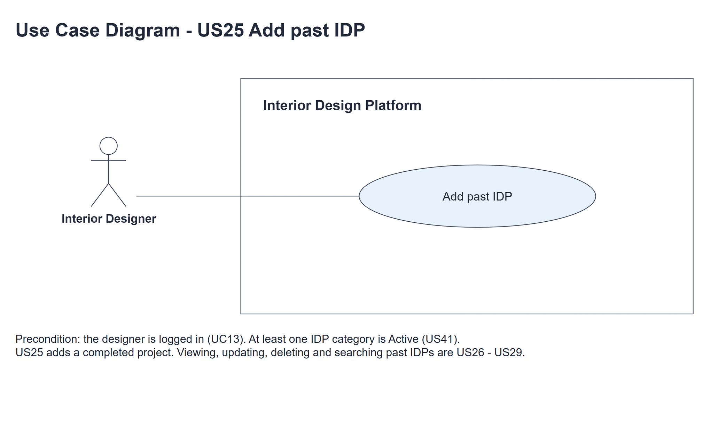
Figure 1: Use case diagram for US25 Add past IDP

3. Use case description
Use case | UC25 Add past IDP
Actor | Interior Designer
Brief description | The Interior Designer adds a project they have completed, so customers can see their past work.
User story | US25: As an interior designer, I want to add a past IDP so that I can show customers my completed work.
Preconditions | The Interior Designer is logged in (UC13). designerLoginRequired in app.py only sends someone with no session to /designer/login.
Trigger | The Interior Designer clicks "Add past IDP" on the dashboard or "+ Add past IDP" on the past IDPs list.
Basic flow | 1. The Interior Designer clicks "Add past IDP".  2. The system gets the IDP categories and keeps the Active ones, sorted by name.  3. The system shows the add form with the category drop-down.  4. The Interior Designer fills in the project details, chooses a category and clicks "Add past IDP".  5. The system trims the input, puts it in a past IDP owned by the logged-in designer and checks the fields (required fields, lengths and that the category is one of the Active ones).  6. The system saves the IDP as a Past, Active IDP if its category is still Active.  7. The system shows the past IDPs list with "Past IDP added successfully".
Alternative flows | 3a. There are no Active IDP categories: the system shows "No IDP categories are available yet. Please try again later" instead of the form. The use case ends.  4a. The Interior Designer clicks "Cancel": the system goes back to the past IDPs list and nothing is saved.  5a. A field is wrong (including a category that was suspended meanwhile): the system shows "Please fill in all required fields", highlights the wrong fields and keeps what was typed. Back to step 4.  6a. The save fails (the category was suspended between steps 5 and 6): the system shows "Past IDP could not be added. Please try again". Back to step 4.
Postconditions | A new past IDP is saved as Past and Active, owned by the designer and linked to an Active category.  It is first in the designer's past IDPs list (US26), and customers can find it (US31).

4. Wireframes
The wireframes were drawn in draw.io. They are low-fidelity: they show the layout and the flow, not the final colours. The orange numbers match the notes under each screen.

4a - Add form
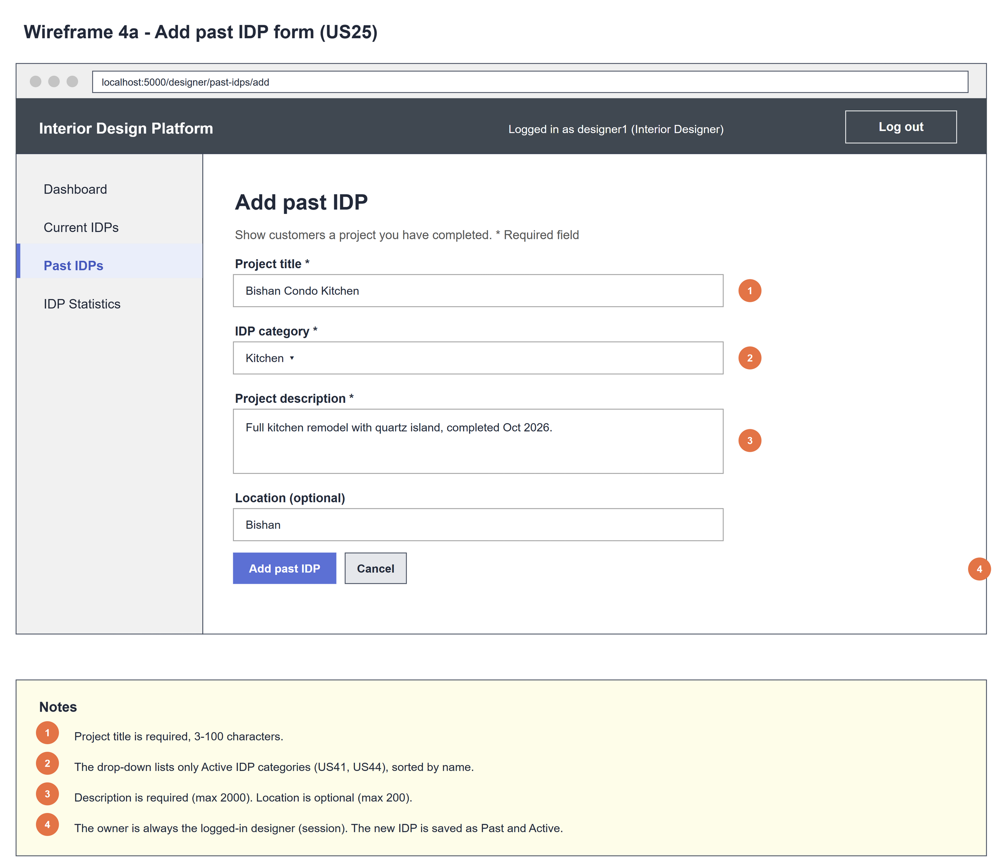
Figure 2: Wireframe 4a - Add form (US25)

4b - Form errors
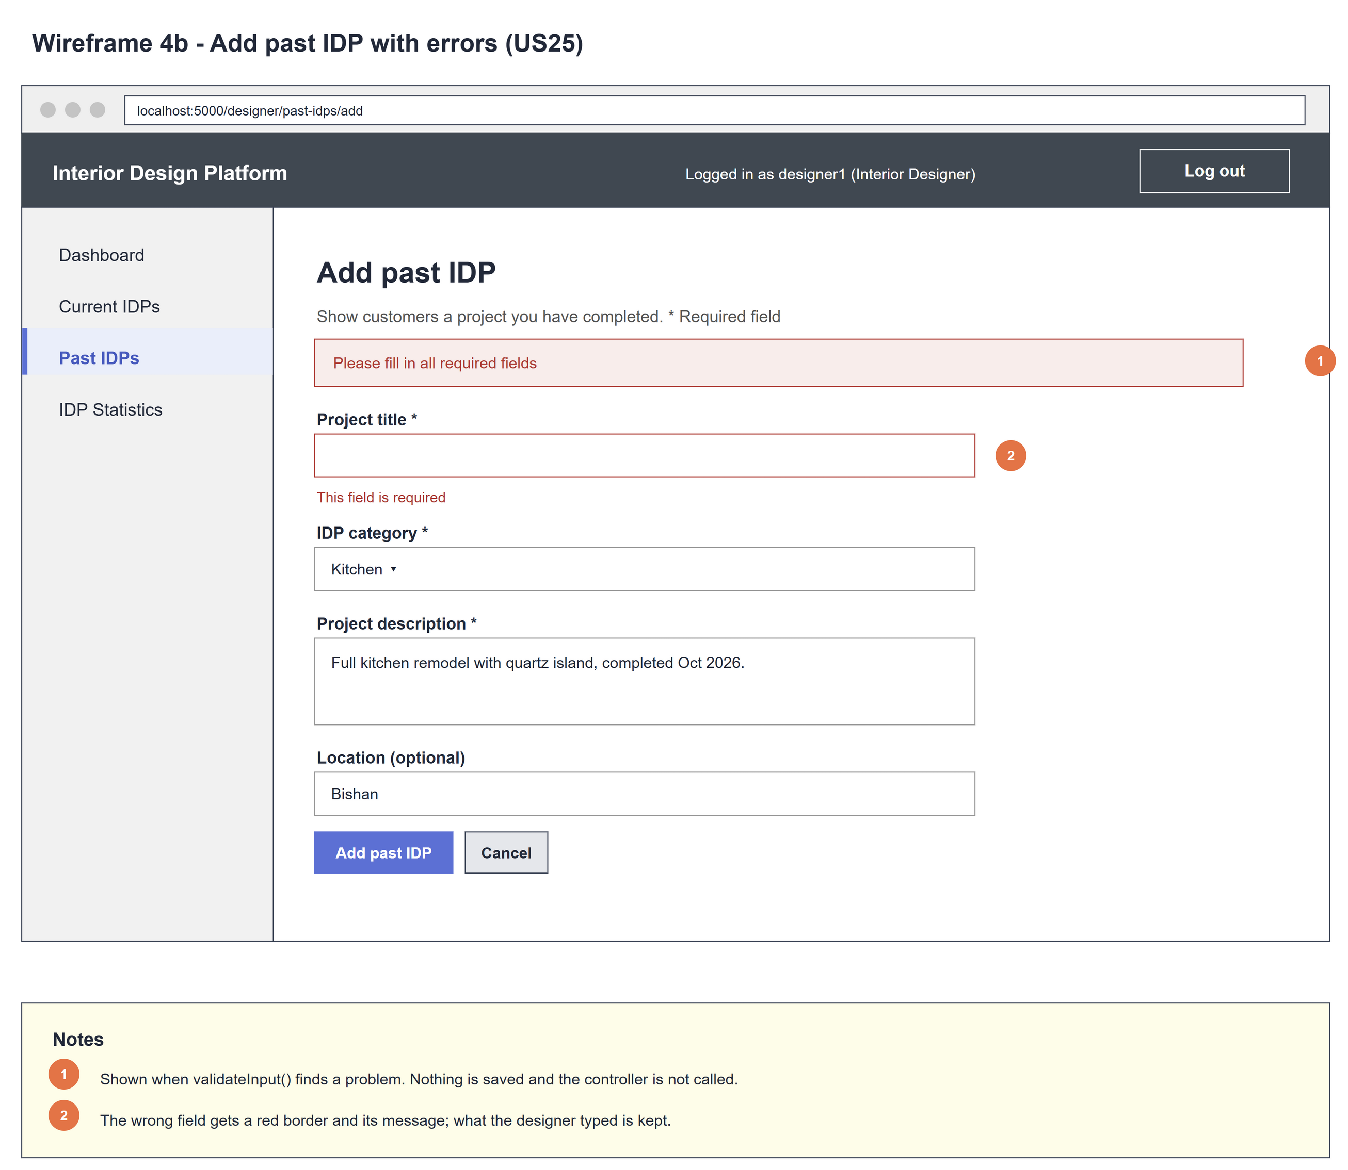
Figure 3: Wireframe 4b - Form errors (US25)

4c - Past IDP added
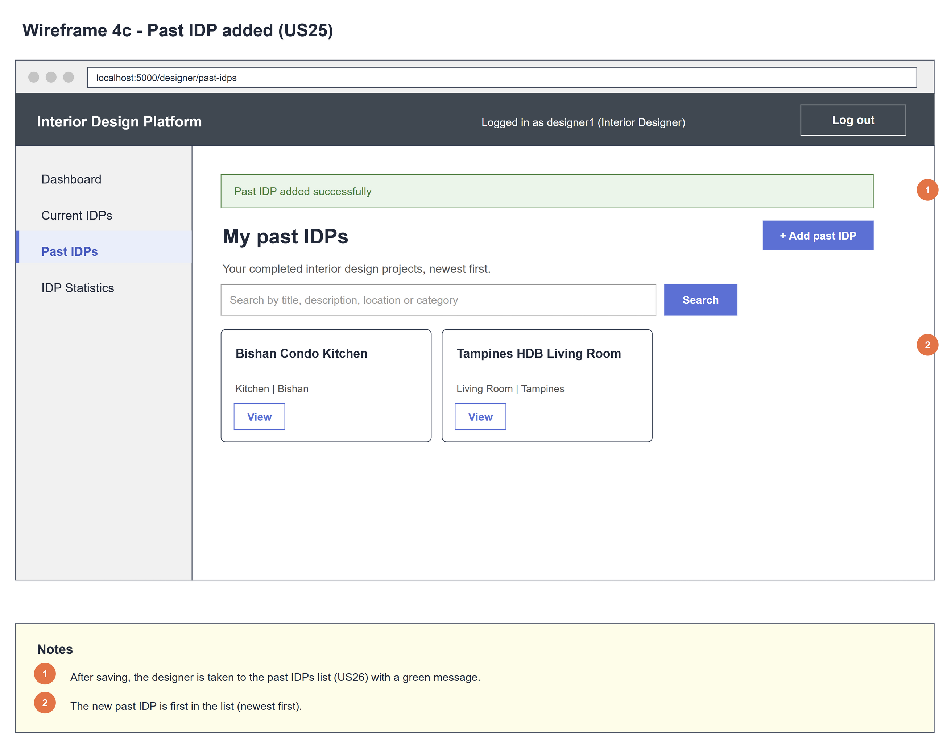
Figure 4: Wireframe 4c - Past IDP added (US25)

5. B-C-E class diagram
The solid lines mean the boundary calls a controller: its own AddPastIDPController, and US45's SearchIDPCategoryController for the category drop-down. The dashed line means the controller uses the entity. Only the operations needed for this use case are shown, with the same names as the code.
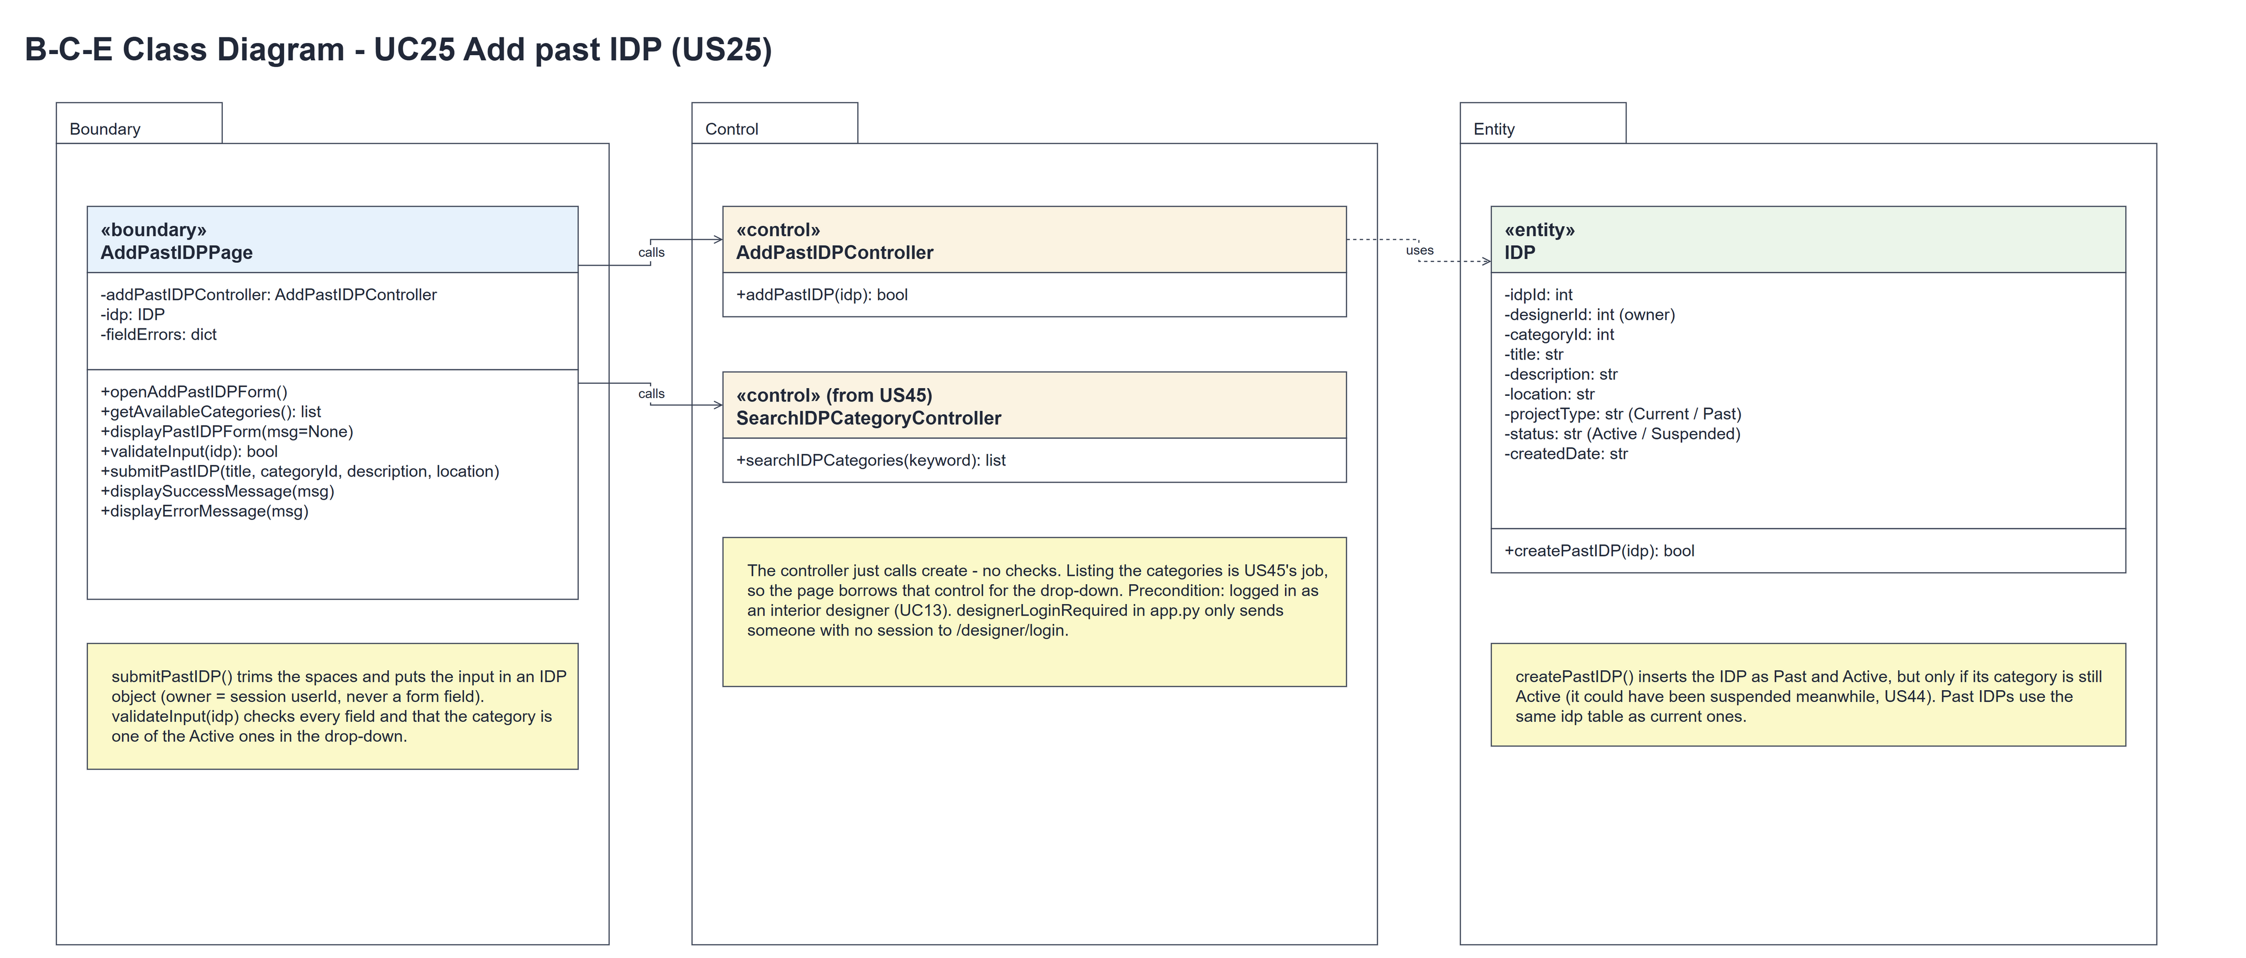
Figure 5: B-C-E class diagram for US25 Add past IDP
Layer | Class | What it does
Boundary | AddPastIDPPage | The add form. openAddPastIDPForm() shows displayPastIDPForm(); getAvailableCategories() borrows US45's searchIDPCategories("") and keeps the Active ones, sorted by name. submitPastIDP(title, categoryId, description, location) trims the input and puts it in an IDP object (owner = session userId, projectType Past), validateInput(idp) checks the fields and the category (wrong -> displayErrorMessage(MSG_FIX_FIELDS)), then the page calls the controller and shows displaySuccessMessage(MSG_ADDED) or displayErrorMessage(MSG_FAILED). No Active category -> MSG_NO_CATEGORIES and no form.
Control | AddPastIDPController | Controller for UC25. addPastIDP(idp) just calls IDP.createPastIDP(idp) and returns the result - no checks.
Control | SearchIDPCategoryController (from US45) | searchIDPCategories("") lists every category; the page keeps the Active ones for the drop-down and for checking the chosen category.
Entity | IDP | The only entity. One row of idp. createPastIDP(idp) inserts a Past, Active IDP only if its category is still Active.

6. Sequence diagram
The sequence diagram follows UC25. Opening the form borrows the US45 controller to list the categories and keeps the Active ones (steps 1-2); the first alt shows the form (step 3) or the "no categories" message (3a). On submit the page trims the input, puts it in an IDP and validates it (step 5) - validateInput() borrows the categories again to check the chosen one. The outer alt saves when the input is valid (the controller just calls the entity, step 6); the inner alt shows the redirect with "Past IDP added successfully" (step 7) or the save error (6a). Invalid input shows the field errors (5a).
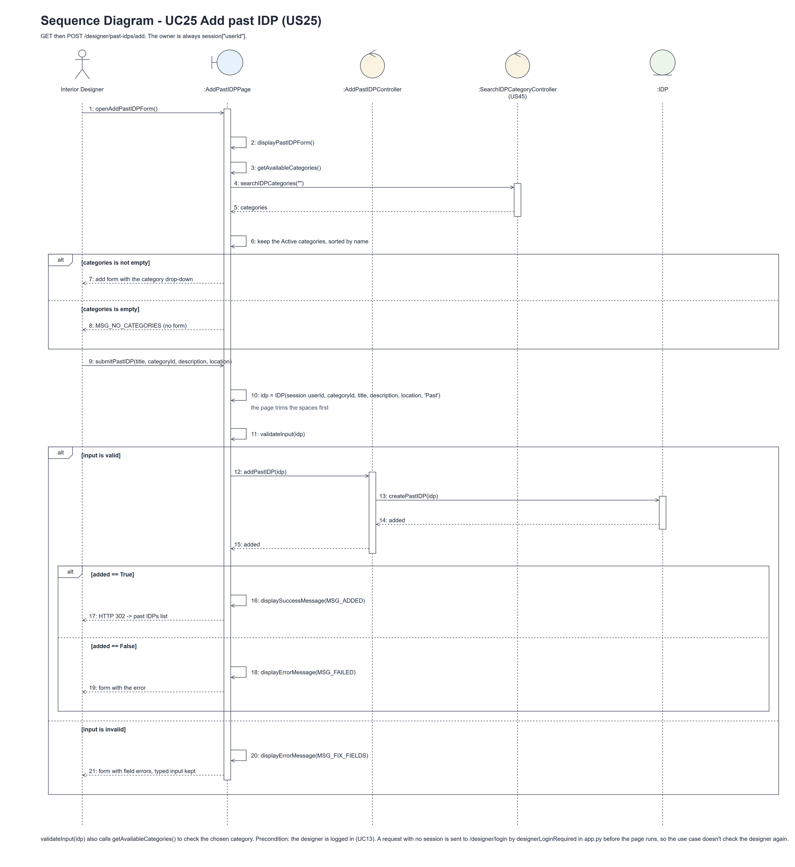
Figure 6: Sequence diagram for UC25 Add past IDP

7. Test cases
Test data used below: the designer account designer37 / Design@123 (Interior Designer profile, made with UC8 - the same account as tests/test_us25_addPastIDP.py) and a second designer designer25b. IDP categories made with UC41: Living Room and Kitchen (Active) and Old Style (Suspended). Past IDP data (from the team's first Sprint 4 test): "Modern 4-Room HDB Resale Transformation", Living Room, "Complete overhaul of a 20-year-old resale flat featuring open-concept layout and minimalist styling.", Tampines GreenVerdant.

7a. System test cases (black box)
Equivalence partitioning and boundary value analysis were used to pick the test data. Fill in "Actual result" and "Pass/Fail" after running each test.
Test ID | Scenario | Prerequisites | Test steps | Test data | Expected result | Actual result | Pass / Fail
TC25.1 | Add a past IDP | Logged in as designer37. Living Room is Active. | 1. Click "+ Add past IDP" / 2. Fill in the form / 3. Click "Add past IDP" | Past IDP data above | The past IDPs list with "Past IDP added successfully"; the IDP is first in the list, saved as Past and Active and owned by designer37.
TC25.2 | Required field missing | As TC25.1. | 1. Leave the title empty / 2. Click "Add past IDP" | Title empty, the rest as above | "Please fill in all required fields" and "This field is required" under the title. What was typed is kept. Nothing saved.
TC25.3 | Title too short (boundary) | As TC25.1. | 1. Enter the title / 2. Submit | "Ab" (2 chars) | "Title must be 3-100 characters". Nothing saved.
TC25.4 | Fields too long (boundary) | As TC25.1. | 1. Enter the values / 2. Submit | 101-char title; 2001-char description; 201-char location | "Maximum 100 characters", "Maximum 2000 characters", "Maximum 200 characters". Nothing saved.
TC25.5 | No category chosen | As TC25.1. | 1. Leave the category on "-- Choose a category --" / 2. Submit | - | "Choose an available category". Nothing saved.
TC25.6 | Only Active categories offered | Old Style is Suspended. | 1. Open the form | - | The drop-down has Kitchen and Living Room, not Old Style.
TC25.7 | No categories yet | No Active IDP categories. | 1. Open the form | - | "No IDP categories are available yet. Please try again later" and no form.
TC25.8 | Location is optional | As TC25.1. | 1. Leave Location empty / 2. Submit | No location | Saved.
TC25.9 | Spaces are trimmed | As TC25.1. | 1. Type the title with spaces around it / 2. Submit | " Bishan Condo Kitchen " | Saved as "Bishan Condo Kitchen".
TC25.10 | Owner can't be forged | As TC25.1. | 1. Add designerId of designer25b to the post / 2. Submit | Forged designerId | The past IDP is owned by designer37.
TC25.11 | Not logged in | Not logged in. | 1. Open /designer/past-idps/add | - | The designer login page is shown.

7b. Unit test cases (for TDD)
These are written before the code (test-driven development) and run automatically in the CI pipeline. They cover normal inputs, abnormal inputs and boundary values. Each one matches a test function in tests/test_us25_addPastIDP.py (UT25.1 is test_ut25_1_...). "Pass" is from the pytest run on 10 November 2026.
Test ID | Class and method | Input / setup | Expected output | Type | Pass / Fail
UT25.1 | IDP.createPastIDP(idp) | designer37, Kitchen Active, valid IDP | True. Saved as Past and Active, owned by designer37 | Normal | Pass
UT25.2 | IDP.createPastIDP(idp) | Category Old Style (Suspended) | False. Nothing saved | Abnormal | Pass
UT25.3 | AddPastIDPController.addPastIDP(idp) | Valid IDP | True - passes the IDP straight to the entity; the row is saved | Normal | Pass
UT25.4 | AddPastIDPPage.validateInput(idp) | Valid; blank title and description; title "AB"; categoryId 999 | True; "This field is required" for both; "Title must be 3-100 characters"; "Choose an available category" | Boundary | Pass
UT25.5 | AddPastIDPPage.openAddPastIDPForm() | Kitchen Active, Old Style Suspended | The form lists Kitchen, not Old Style | Normal | Pass
UT25.6 | AddPastIDPPage.displayPastIDPForm() | No categories | "No IDP categories are available yet. Please try again later". No form | Boundary | Pass
UT25.7 | AddPastIDPPage.submitPastIDP() | Valid data | Redirect to the past IDPs list with "Past IDP added successfully"; owner designer37 | Normal | Pass
UT25.8 | AddPastIDPPage.submitPastIDP() | Title empty | "Please fill in all required fields", the typed description kept, nothing saved | Abnormal | Pass
UT25.9 | AddPastIDPPage.submitPastIDP() | Forged designerId of designer25b in the form | The owner is still designer37 | Abnormal | Pass
UT25.10 | /designer/past-idps/add (designerLoginRequired) | Not logged in | Redirects to /designer/login | Abnormal | Pass

